How to install Xilinx ISE

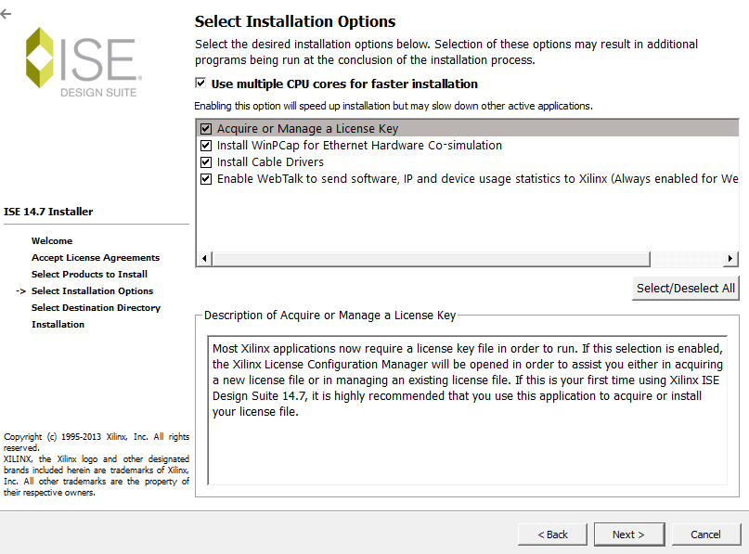

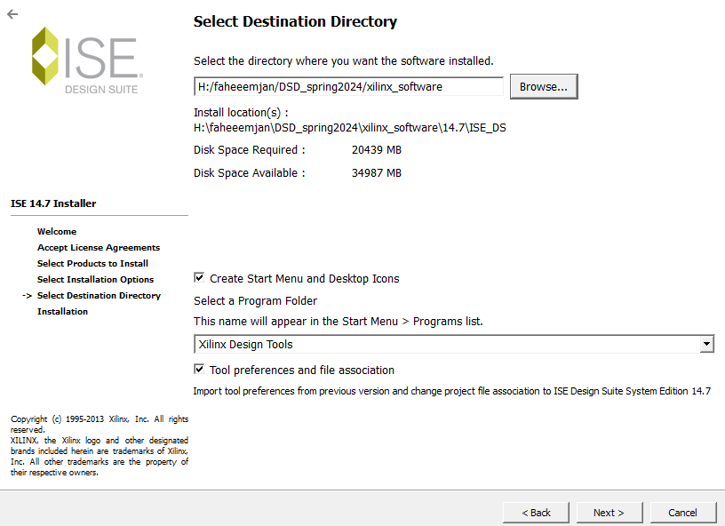

There should be no space in the name of the folder



After this H:\faheeemjan\DSD_spring2024\xilinx_software\14.7\ISE_DS got this path then ISE then lib folder then nt64 folder then inside this folder select libPortability.dll and rename it to libPortability.dll.orig and then press enter

then select the libPortability-NOSH.dll and copy it and paste it and then change the copied to libPortability.dll

now copy the libPortabilityNOSH and then go to common folder instead of ISE and nt64 folder and then paste it and here first change libPortability.dll to libPortability.dll.orig and paste the file and change the name to libPortability.dll that’s it .